Board Meeting
January 2023

Agenda

Welcome and Happy New Year!

Financial Dashboard
Finished the year strong! 100K over Budget

Acceptance for 2023 has begun!

Great things happening!
Two new couples retreat locations- Fort Morgan, AL and Northern Outer Banks (Carova Beach- 4x4 horse area)

Update on Application and Acceptance processes to be in line with our mission of increasing and valuing diversity across the organization.

Travel Initiative Updates
Program is Online and will accept applications starting Jan 31st!
Advisory team is AMAZING!
- 65% of participants are self reporting that they are interested in travel initiative
- Anticipate 50% eligible
We have secured $140 in funding thus far
- $75K Tap Cancer Out- partnership based out of Charlotte, NC
- $30K Pledge the Pink- event in 2023 in Oak Island
- $40K Fishing for a Cure- long time partnership gave for this initiative

Time for us to look at cross support for these organizations
Monday, April 17th Charity Classic Golf Tournament at Firethorne Country Club in Charlotte hosted by Tap Cancer Out- would love for us to enter a team to play (2K)
Tap Cancer Out has potential to be a $125-$150K funder next year if we create a great partnership.

Saturday, March 25th Charlotte- our first event! Passion for Fashion- hosted by Mix 107.5 Madison James. Atlanta designer and an entire new group of people. Great potential for growing our participant, volunteer and funding base.

Friday, March 31st at Mill Creek Golf Club- golf tournament is LIVE for registration! $125 per player/ $500 per team. This is a benefit for corporate sponsors

Wigging Out Update
101 individuals / starts February 1- goal is $150,000!

Dancing with the Stars Update
Current Dancers that have said yes:
Maghon Taylor- All She Wrote Notes
David Riley- Mebane business owner
Dr. Dempsey Smith- orthodontist
Debin Warren- breast cancer survivor
Natalie Hunt- owner of Nat Pack’s

Board Recruitment Plan

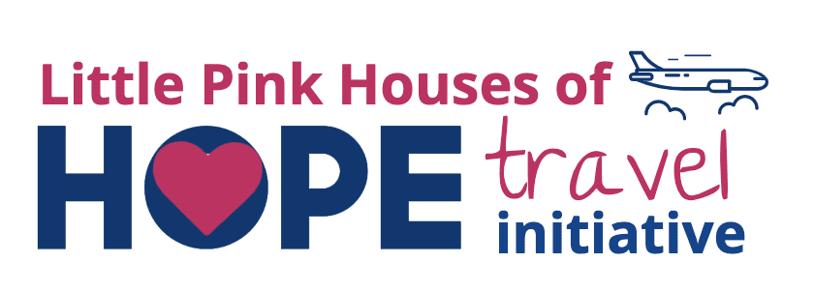
Financial hardship should not keep you from being able to attend a Little Pink retreat. We understand the financial toll that cancer can have on a family and have developed a program to help curb the out-of-pocket costs of travel expenses for individuals and families.

Eligibility
- You must be accepted for a Little Pink retreat. Please do NOT fill this application out if you have not received an email with your retreat assignment.
- Currently in treatment for breast cancer or living with metastatic (Stage IV) breast cancer.
- Have a current annual household income at or below 300% FPL
- Reside in the United States or US Territory,
- Funding is only for participant and individuals included on their tax returns.

Process
- Submit online form including all relevant documentation
- Failure to complete the documentation by the deadline set forth or providing false or misleading information will make the participant ineligible for assistance. The participant will also agree to provide additional information as needed.
- Little Pink will review the form and documentation and provide assistance if applicable.
- Little Pink Houses of Hope Travel Assistance Program’s continuation is dependent on the availability of funds and reserves the right to modify and/or discontinue the program at any time and without any prior notice to applicants.

Redemption
- Little Pink will provide financial assistance to be used strictly for attending an assigned Little Pink Retreat. Funds can be used for the following:
  - Gas
  - Flights
  - Baggage Fees
  - Ferry and or Taxi fees
  - Uber rides
  - Rental Car
  - Train ticket
  - Hotel while traveling to/from the retreat
  - Travel incidentals (meals and snacks)

Funding is limited and is not guaranteed. The Travel Assistance Program is based on the availability of funds and the demonstration of financial need.

APPLICATION FOR ASSISTANCE OPEN JANUARY 30, 2023

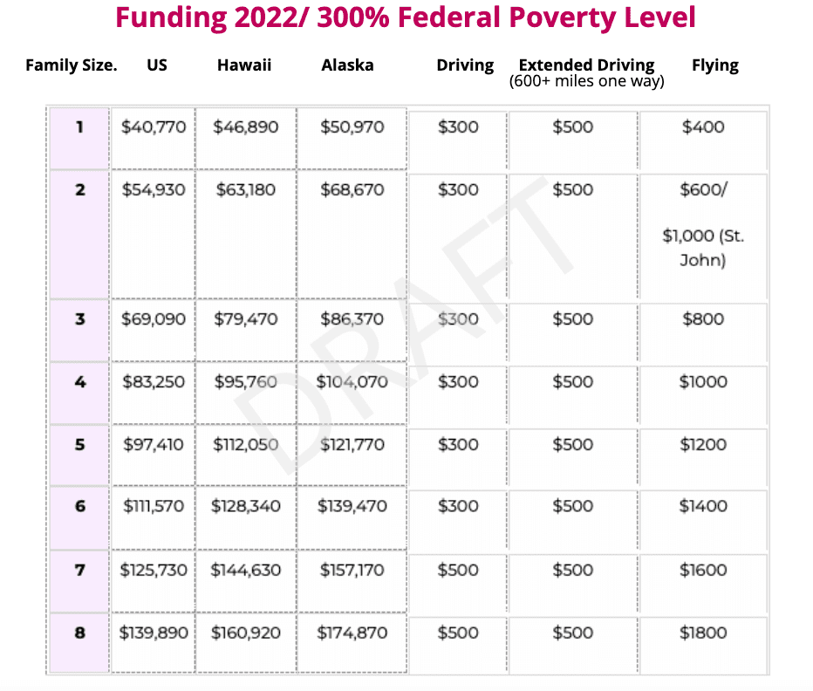
This is the 2022 Federal Poverty Level Guidelines Chart. The 2023 Chart will be posted by the end of January 2023.

