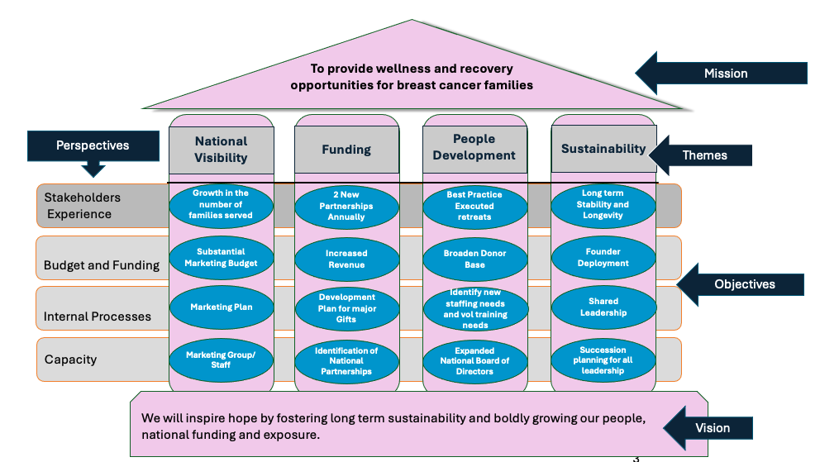

Stakeholders: Area Based Planning and Funding Delivery
Project: Equipping new supervisors to identify possible funding sources in retreat areas
Person: Retreat Supervisors
Date Completed: Feb 1, 2025
Metric: training the 4 supervisors to identify

Budget and Funding: Annual Fund Increases
Project: Monthly meetings for development
Person: Joanne/ Board of Directors
Date Completed: Start Jan 2025
Metric:

Internal Processes: Development plan for major gifts
Project: Monthly meetings for development
Bring gifts up a level and small foundation gifts/ Board member has 2 asks per month with an accountability structure
Person: Joanne/ Board of Directors
Date Completed: Start Jan 2025
Metric:

Capacity: Ongoing Identification of National Partnerships
Project: Identify and timeline for the ask
Person: Jeanine
Date Completed: December 2025
Metric: 2 National Partnerships at $50,000+

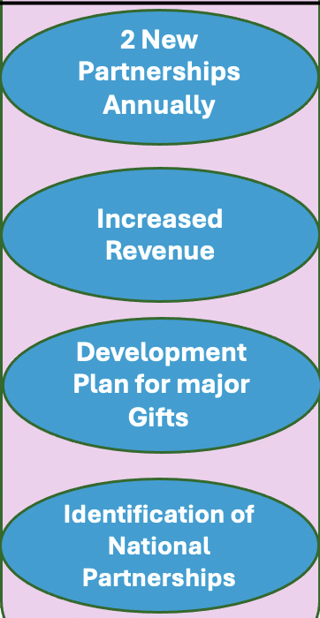
FUNDING
Stakeholders Experience: Best Practices Executed Retreats
Project: Created a list of projects and prioritizing them for the board (with coordinators and directors) and make recommendation to the board
Person: Kathy Gates
Date: Feb 15
Metric: $25,000 raised by the board. Choose 1 project to tackle for 2025

Budget and Funding: Budget Increase
Project: Approve 2025 Budget
Person: Board of Directors
Date: Nov 2024
Metric: completed budget/ increase by $25,000

Internal Processes: Focused Staff and Development
Project: Lead staff work group that determines the personnel growth and volunteer development. What training is needed by current staff?
Person: Leslie
Date: Feb 15
Metric: What are the next 2-3 positions needed for the next 3-5 years

Capacity: Expanded National Board of Directors
Project: Networking Tree session for New Board Members/ Identify 4-5 new board members to achieve a 40% national composition
Person: Bryan and Julie
Date: March 31
Metric: Identify and secure 4-5 new board members to achieve a 40% national composition

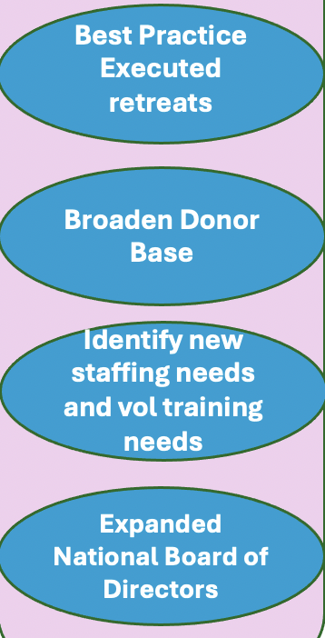
PEOPLE DEVELOPMENT

Budget/ Funding: Founder Deployment
Project: Job Description for Jeanine/ Identify how to get freedom for Jeanine so that she can redploy beginning in 2025. Shared responsibility or VP position.
Person: Executive Committee
Date: July 1, 2025
Metric: free up 25% of Jeanine’s time

Internal Processes: Shared Leadership/ Defined Roles
Project: Develop roles of board members and develop an on-boarding plan with appropriate materials
Person: Adam Willets (Julie will give United Way packet)
Date: by Dec 31, 2024
Metric: completed materials

Capacity: Succession Planning
Project: Development of Work Group with a first meeting completed
Person: Brad Shaw and a Board member
Date: Feb 28, 2025
Metric: meeting completed

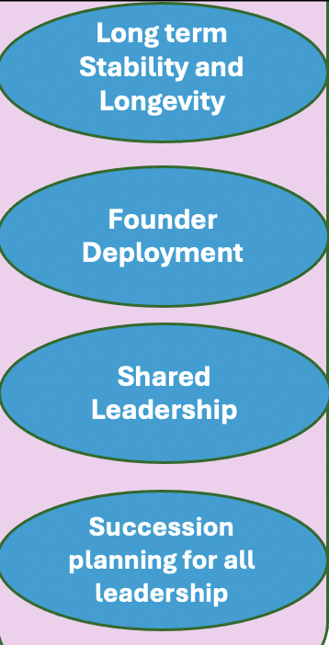
SUSTAINABILITY

Stakeholders Experience: Growth in the number of families served
Project: Completion of 2025 New Retreat Locations
Growth and the Development in the number of retreats- 2 per year (2026)
Person: LP Staff
Date Completed: January 2026
Metric: retreats scheduled with proper support

Budget and Funding: Substantial Marketing Budget and Funding Opportunities
Project: Development of 5 Funding Opportunities
Person: Bryan and Jeanine/ Marketing Work Group
Date Completed: November 31, 2025
Metric:

Internal process: Marketing Plan and Direction
Project: Delivery and Acceptance of marketing plan / figure out staffing needs
Assessing the current social media model and current marketing materials
Look at the layers and how to increase visibility
Person: Bryan and Jeanine/ Marketing Work Group
Date Completed: June 30, 2025
Metric: Delivered plan

Capacity: Marketing Work Group/ Staff
Project: Establish a Work Group and give them a charge and direction/ Need board Leader for group
Person: Bryan and Jeanine
Date Completed: by end of February 2025
Metric: 6 people secured for group

NATIONAL VISIBILITY
