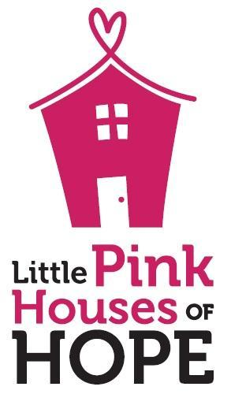  Our Mission is to promote breast cancer recovery by offering opportunities for survivors to reconnect and celebrate life. |  | Little Pink Houses of Hope  2442 Tribek Court  Burlington, NC 27215  Little Pink Houses of Hope is non-profit organization that provides FREE weeklong vacations for breast cancer patients and their families. We believe a cancer diagnosis does not just affect the patient, but the entire family. Every retreat is designed to help families relax, reconnect, and rejuvenate during the cancer journey. We are excited about our upcoming retreats May 11-18th (Couples Retreat) and Nov 2-9, 2024 (Family Retreat) in New Smyrna Beach, FL. There are many organizations that focus on raising money for a cure or resources for patients, but very few that focus on creating a successful, healthy survivorship experience for the entire family as they navigate the cancer journey. Cancer is physically, emotionally, and financially exhausting. In the first 13 years we have been able to send over 1,400 families to a retreat for a week that they will forever remember. The financial burden of every aspect of a vacation is removed so that families can relax, reconnect, and rejuvenate in a world free of appointments, doctors, and daily demands.  We are asking for your support! Our retreats leverage the compassion of generous donors to provide for our families in need. Our model is successful because of wonderful individuals, local businesses and organizations that provide houses, meals, activities, and financial support for our retreats. Little Pink Houses of Hope is a 501©3 organization and all financial donations and donations of goods and services are tax deductible.  Your generosity will help us continue to provide retreat opportunities for breast cancer families. Please feel free to contact me if you have any questions.  Thank you for your support!  Sincerely,  Doris Harrington Tara Galloway  (386) 689-0228 (386) 576-4092  doris@littlepink.org tara@littlepink.org  New Smyrna Beach, FL Family Coordinator New Smyrna Beach Couples Coordinator

