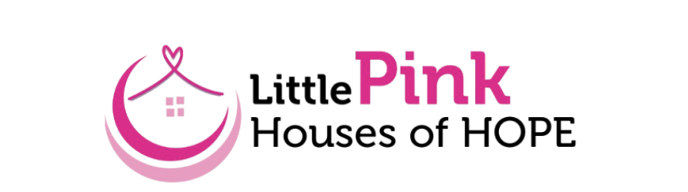
Brand, PR and Visibility Work Group Agenda
Thursday, August 28th at 11:00am
Zoom

Meeting Agenda
- Welcome & Introductions
- Project Updates
  - Susan and Rob update status on interviews
  - Check-in with Jeannine and Atilia on audience mapping
- Month 4 Planning: Building a National Framework & PR Strategy
  - Discuss overall capacity
  - Develop templates for press kits ahead of fall and Breast Cancer Awareness season
    - Identify potential national outlets- If you have contacts, please email those to me ahead of the meeting on Thursday.
  - Review and discuss other updates to website and social media platforms
    - What steps do we take to get these updates completed?

Next Steps & Action Items- are we ready to move into

Month 5: Corporate & Strategic Partnerships Plan or should we think about rearranging our monthly plan to work towards our Month 6: Influencer & Ambassador Strategy

