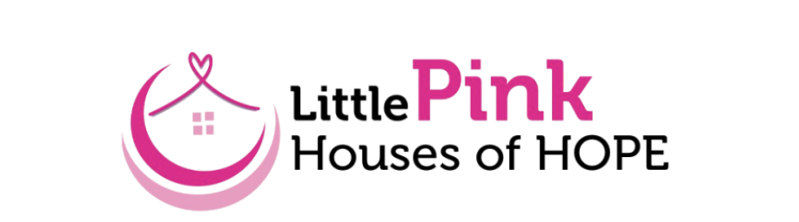
Brand, PR and Visibility Work Group Agenda
Thursday, July 17th at 11:00am
Zoom

Meeting Agenda
- Welcome & Introductions
- Project Updates
  - Check-in with Susan and Rob on interviews
  - Check-in with Jeannine and Atilia on audience mapping
- Month 4 Planning: Building a National Framework & PR Strategy
  - Discuss overall capacity
  - Develop templates for press kits ahead of fall and Breast Cancer Awareness season
    - Identify potential national outlets
  - Review and discuss other updates to website and social media platforms
- Next Steps & Action Items

