Definition of Audience and Marketing Audit
- Audience:
  - It's important that we distinguish between those we serve and those whose support we need.
  - We serve breast cancer families.
  - Our communications' audience goes beyond this group, however. I believe it hits these criteria:
    - Past givers.
      - All givers
      - Those who have given the most (can we assess the top 10% of givers, then build a look-alike audience)
    - Hand raisers:
      - Anyone who has participated in breast cancer events or been involved with relevant organizations
    - Potential givers:
      - High-income and high-wealth executives who have a history of donating to cancer awareness activities (again, building look-alike audiences)
      - Those with a personal connection (survivors and their families)
    - Corporate philanthropy: We need to find the foundations that have earmarked these and similar issues as important to them.
- Participants
- Volunteers
- Donors (financial and product)
- Community Members
- Government Entitie

Context
This doc captures high level ideas and suggestions for discussion with regards to target audience and audit. Audit focuses on digital presence and is not intended to be comprehensive. These are thought starters for consideration and discussion.

Audit
- Website
- Content clarity:
  - Issue #1: Currently it takes too long to understand what Little Pink does immediately upon website arrival. You have to scroll down to the end of the page to learn more / watch a video.
- Need clarity—mission is not clear on home page. I have to scroll to the bottom of the page to see exactly what the organization provides.

    - Action: Consider reviewing the website content to ensure that the messaging is succinct and action oriented. Consider a clear Call to Action (CTA) upon website entrance so that visitors can learn more about retreats. Example from NBCF below.
  - Issue #2: Consider what is the purpose of the website and tailor the content/messaging around that. In my experience when I went to the website, I was served a pop-up below but there’s no details about location and it may not be relevant if I’m not in the event location.
    - Action: Consider evaluating what the purpose of the website is and who the messaging is targeted
    - to. 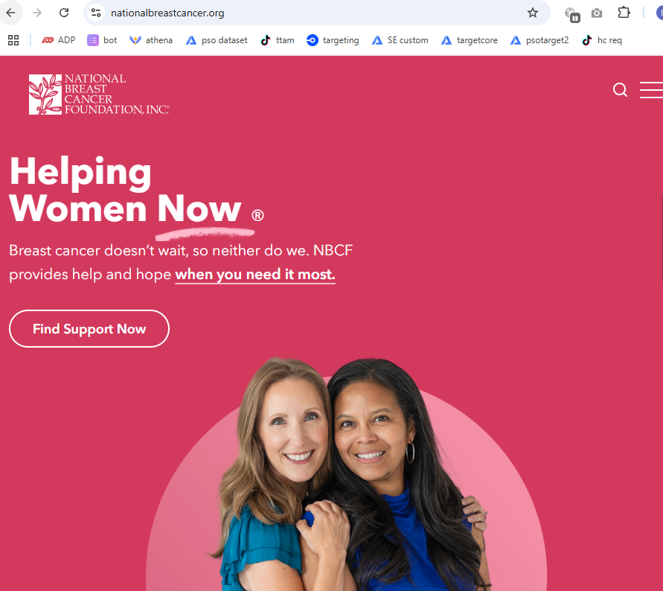
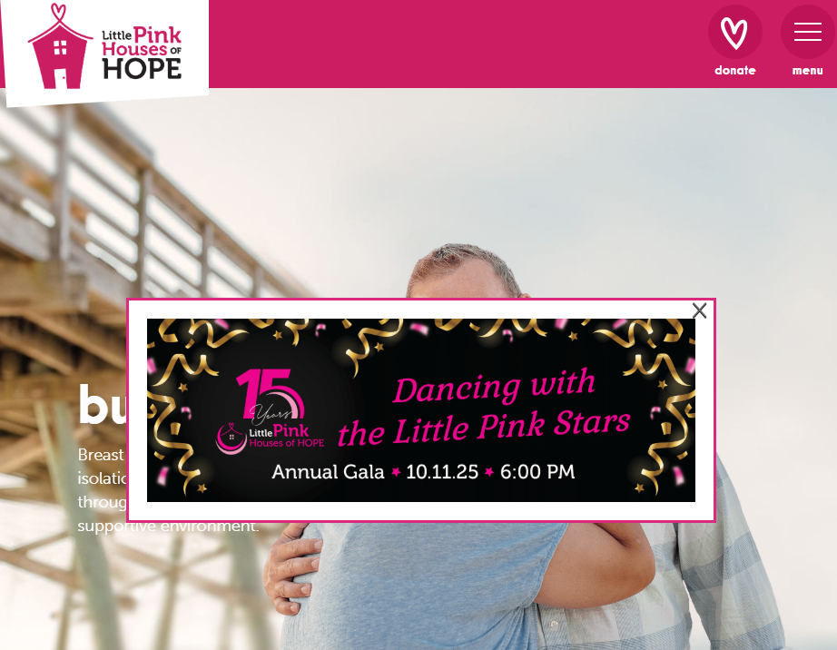
- Donations- Easier way to donate- Old

- SEO Optimization: Although Google search results are personalized at the individual level, below screenshot shows what is shown for me when searching for “Little Pink Houses of Hope.” The circled yellow area is called metadata. A website owner/developer has the control over updating this metadata to reflect in short 1-2 sentences what the org does. Right now this is not a good use of prime meta data real estate.
- Action: Suggest writing new metadata copy that shows 1. Value proposition and 2. Concrete call to action. The meta data used for search keyword “breast cancer trip” is very good. 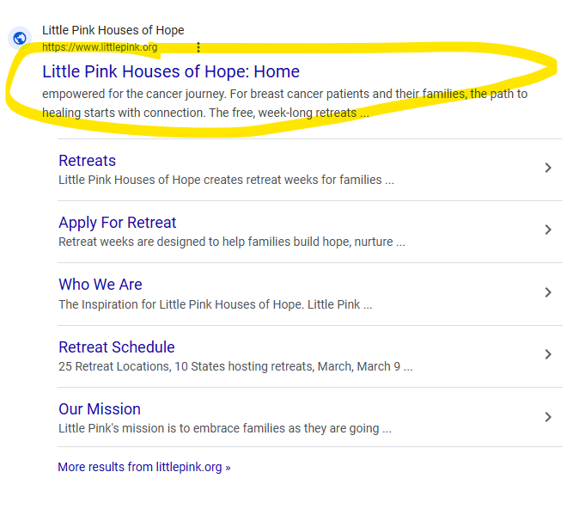
- 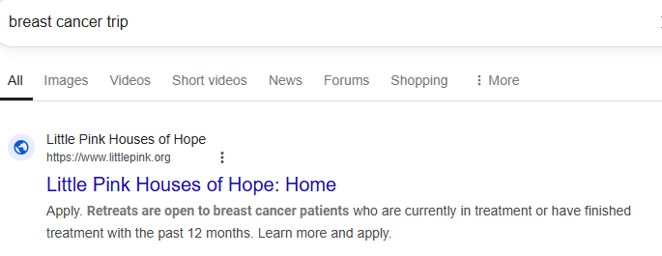

- Social media
  - Consider investing efforts in 2-3 key platforms. It is not scalable or sustainable to invest in too many platforms given that consistent frequency of content matters greatly.
    - Currency Facebook and Twitter are listed. Note Twitter is now X and it is a gated community (ie. only signed up X users can access content).
  - Consider the target audience:
    - Facebook: A35-65, functionality for event promotion and community building (groups)
    - Instagram: A25-45, highly visual/images for storytelling, younger survivors, potential for collaborations with influencers
    - TikTok: A18-35, fast growing platform with strong engagement, lots of “how to” educational content, participating in trends. Younger audiences can also serve as a connection to parents or relatives.
    - YouTube: A25-54, long-form video great for storytelling and discoverability
    - LinkedIn: 30-60, B2B presence, can support professional outreach and corporate sponsorships
  - Consider the objective of each platform and tailor the content to that. Is the objective to educate a mass audience about the existence of free retreats? Is the objective to educate people about the core values and/or mission? Is the objective is to influence prospective donors to donate?

- Other things to consider but not included at this time:
- Content strategy: visual assets, image/video, storytelling, thought leadership
- Analytics, measurement & reporting: Tracking activities on website and/or other communications like e-mail in order to understand how effective are these efforts and how engaged are visitors/viewers/donors? How do these KPIs tie into overarching objectives?
  - Conversion funnel: Understand how donors and visitors experience the journey with Little Pink

5.Branding Strategy: What I see is corporate identity: how it looks, sounds and how the brand behaves. Essentially how the brand shows up in the world to all various stakeholders/audiences that we’re communicating with. Should we consider doing a brand audit?

- Media Coverage: I don’t know what time frame this is referencing. Who is the target for these placements?
- Volunteer : the form is super long to scroll thru.

Additional Thoughts:
- Thoughts about the map:
  - While I love the work that has gone into this, it feels overly complicated for such a small group. For our purposes, we should focus primarily on the organization's mission. But then we must further if we are going to build a message that resonates with our key audiences. To do that, recommend taking these steps:
    - Agree on the core audience
    - Identify our core messages: What is our reason for being, what do we promise people that others don't
    - Describe what makes LPH different. What benefit do we give donors that other similar organizations do not give them?
- The other elements in the map are useful but go beyond this group's focus.

Attila’s late entry audit findings (not included in above compilation)
1. This first one is a channel observation (based on the document “An exploration of the
historical brand visibility and marketing for Little Pink Houses of Hope”). Moving forward,
it may make sense to categorize the current channels (social media, media coverage,
fundraising events, community outreach, etc.) across the PESO model widely used in
the marketing and communications industry. PESO stands for Paid – Earned – Shared
– Owned channels. This is a helpful way to think about visibility in the market. “Paid”
typically refers to things like advertising (since it involves paying for a media
space/airtime) or anything that costs money to buy your way into an audience’s
attention. “Earned” refers to articles, media appearances, interviews, etc. that was
published by a third party without money changing hands (i.e. organic media coverage).
“Shared” refers to messaging shared on social media platforms by others (followers,
influencers, fans, etc.) about us, sometimes without our influence. “Owned” means
channels that we fully control like our own website, our own social media presence,
blogposts published by us, etc.
While it’s admittedly nothing super-scientific per se, the PESO model is a practical way
to get intentional and pragmatic about thinking through our, using marketing lingo,
optimal “channel mix”, as we eventually enter the planning and investment allocation
phase.

2. Facebook presence. Sharing real stories, heartfelt moments, etc. is a great approach.
For some reason, with the exception of mentioning former program participants’ passing
(which seems to get 200+ reactions per post), the posts mostly hover in the 20-40
reactions. Finding a way to increase engagement, primarily through shares, would be
important.
3. Web search and the role of AI in it. At one point, we will want to think through the
conceptual areas/themes that we’d want to be associated with and subsequently be
found for when someone searches the web. Moving beyond being found easily just
under what’s referred to as a “branded search” (i.e. when someone types in “Little Pink
Houses of Hope”) is critically important. Do we want to be found when someone types
“breast cancer charity” in the Google search field? Similarly, do we want to be found

when someone types “Volunteering for breast cancer”? Perhaps not for these specific
conceptual areas but we should brainstorm and then build out a modest keyword pool.
Relatedly, the importance of independent third-party content sources, like Wikipedia,
cannot be overstated. When Google serves up finds in a search, these days what’s at
the top of the page is AI generated long-form answers, with supporting links. Only after
that do we get to see the “usual” Google finds. Therefore, having a very thoughtfully
written Wikipedia page could be instrumental in being found organically.
4. Admittedly, media coverage isn’t exactly easy to attain but I feel it could be one of the
“power channels” in the mix moving forward. It credentializes us more than anything
(especially high-profile coverage like Jeanine’s appearance on the Tamron Hall Show
back in 2023) and it is a powerful tool/addition in high-level donor (corporate)
discussions. In the PESO model (mentioned in the first point at the beginning of this
document), it falls into the “E” (earned) category.
5. Amplification opportunities. Here I’m thinking about brainstorming ways to get the
word out through others who have thousands (millions?) of followers/fans in their own
right. It doesn’t always help with getting the full story across, but it can raise our profile if
perhaps not overnight but certainly over a few quarters. Social media influencers and
celebrities (who care about breast cancer – and there must be dozens of them out
there) could be target audiences. I’ve noted these in the Audience Mapping file.

