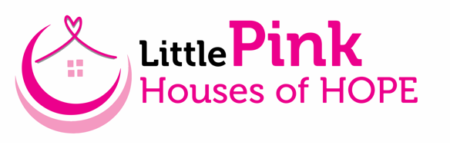

Little Pink Houses of Hope is non-profit organization that provides FREE weeklong vacations for breast cancer patients and their families. We believe a cancer diagnosis does not just affect the patient, but the entire family. We are excited about our upcoming retreat Aug. 15-22, 2026, in Orange Beach, AL, a community that has generously surrounded families with donations of meals, activities, and support. The financial burden of every aspect of a vacation is removed so that families can relax and reconnect for a week - free of appointments, doctors, and daily demands.

We are asking for your support! Our retreats leverage the compassion of generous donors to provide for our families in need. Our model is successful because wonderful individuals, local businesses and organizations provide houses, meals, activities, and financial support for our retreats. Little Pink Houses of Hope is a 501(c)3 organization and all financial donations and donations of goods and services are tax deductible.

Your generosity will help us continue to provide retreat opportunities for breast cancer families. Please feel free to contact me if you have any questions.

Thank you for giving families hope!
Sincerely,

Tracy Stegall
(704) 291-5956
tracy@littlepink.org
Volunteer Retreat Coordinator

www.littlepink.org

